**Ansible:** to manage the code infracture and change the configuration

scripting→ configurations

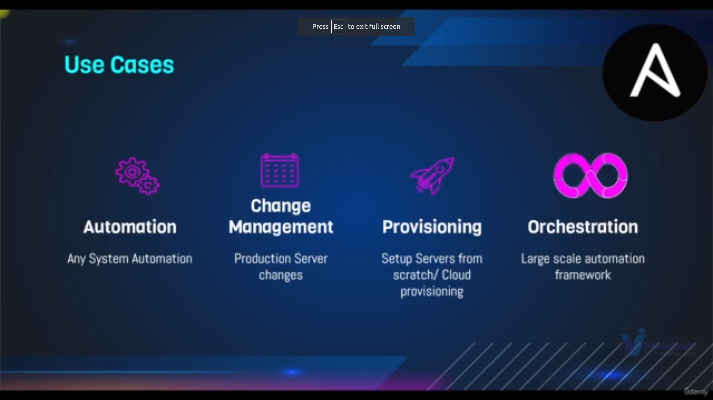uses of ansible

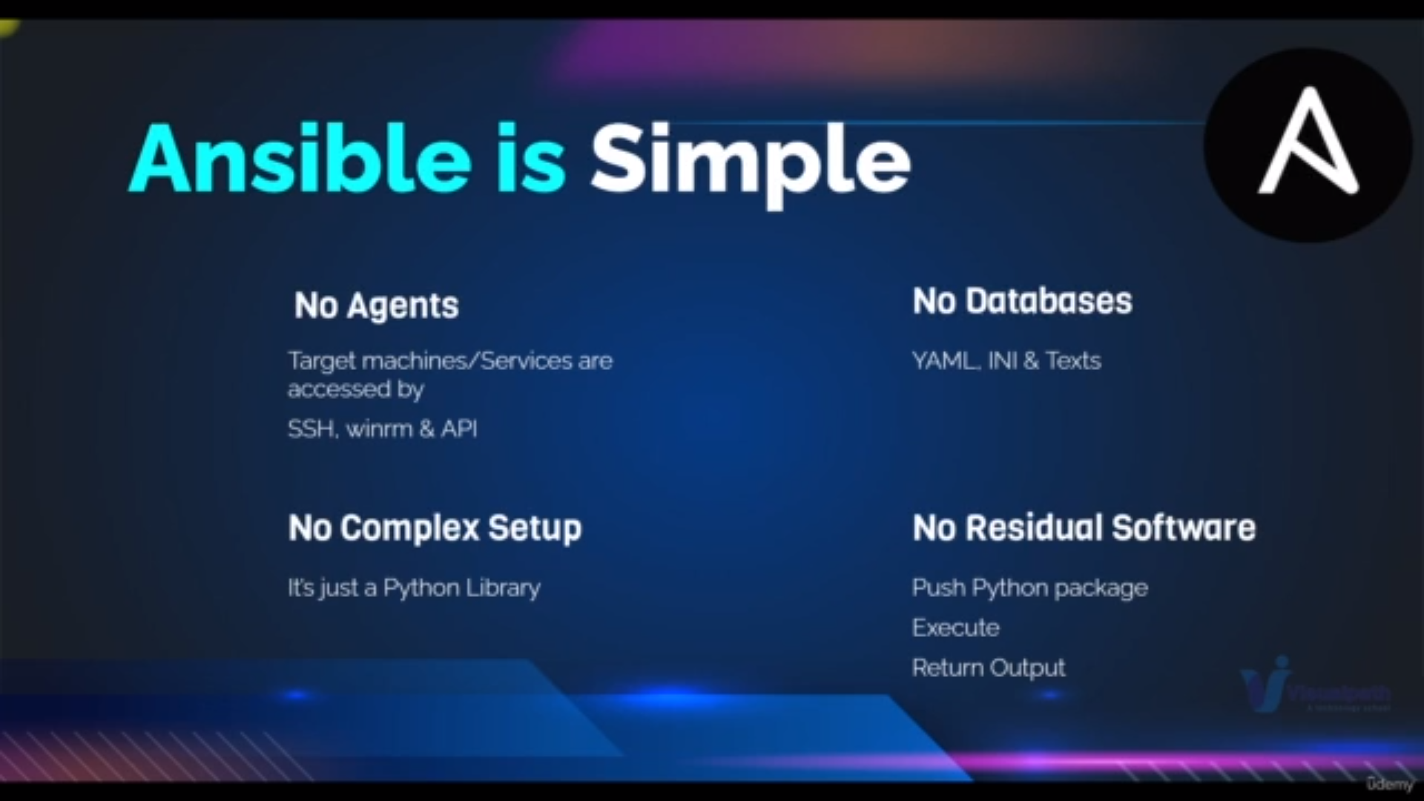ansible connect through ssh connection in linux

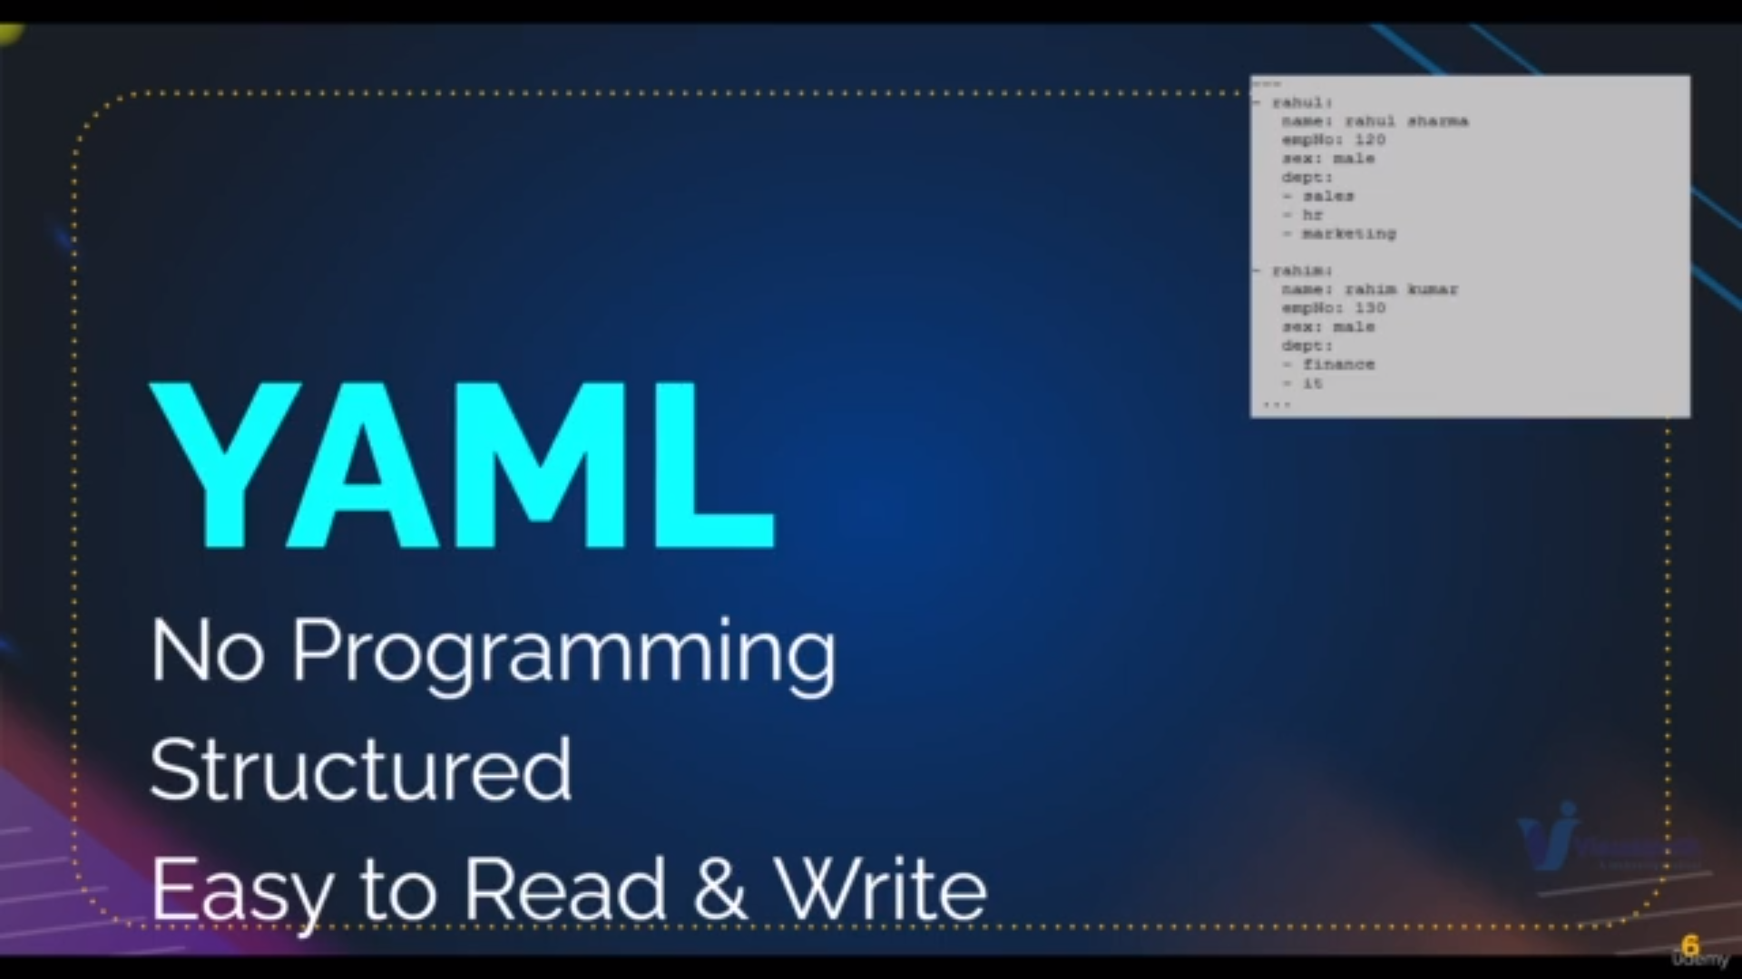ansible needs yaml not programming language

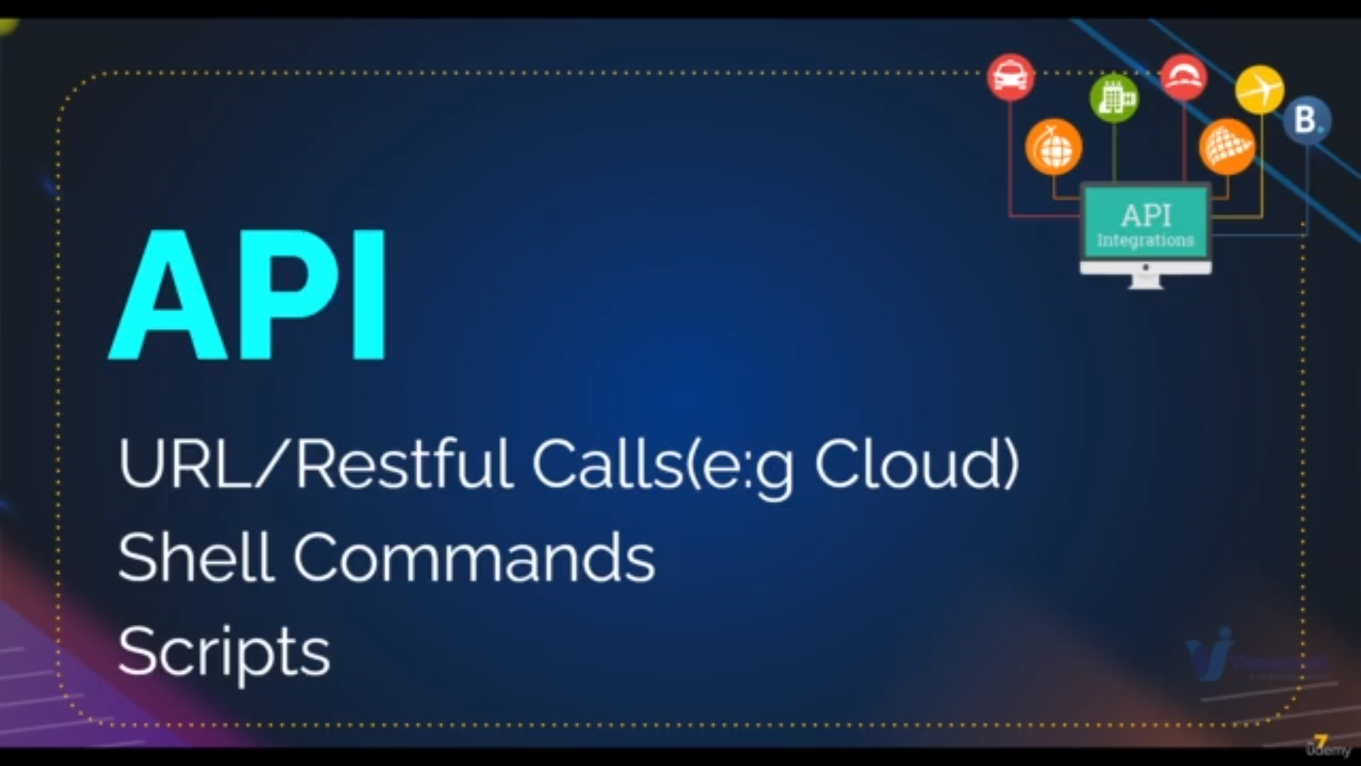ansible uses lot of api like

bottom api is used for aws

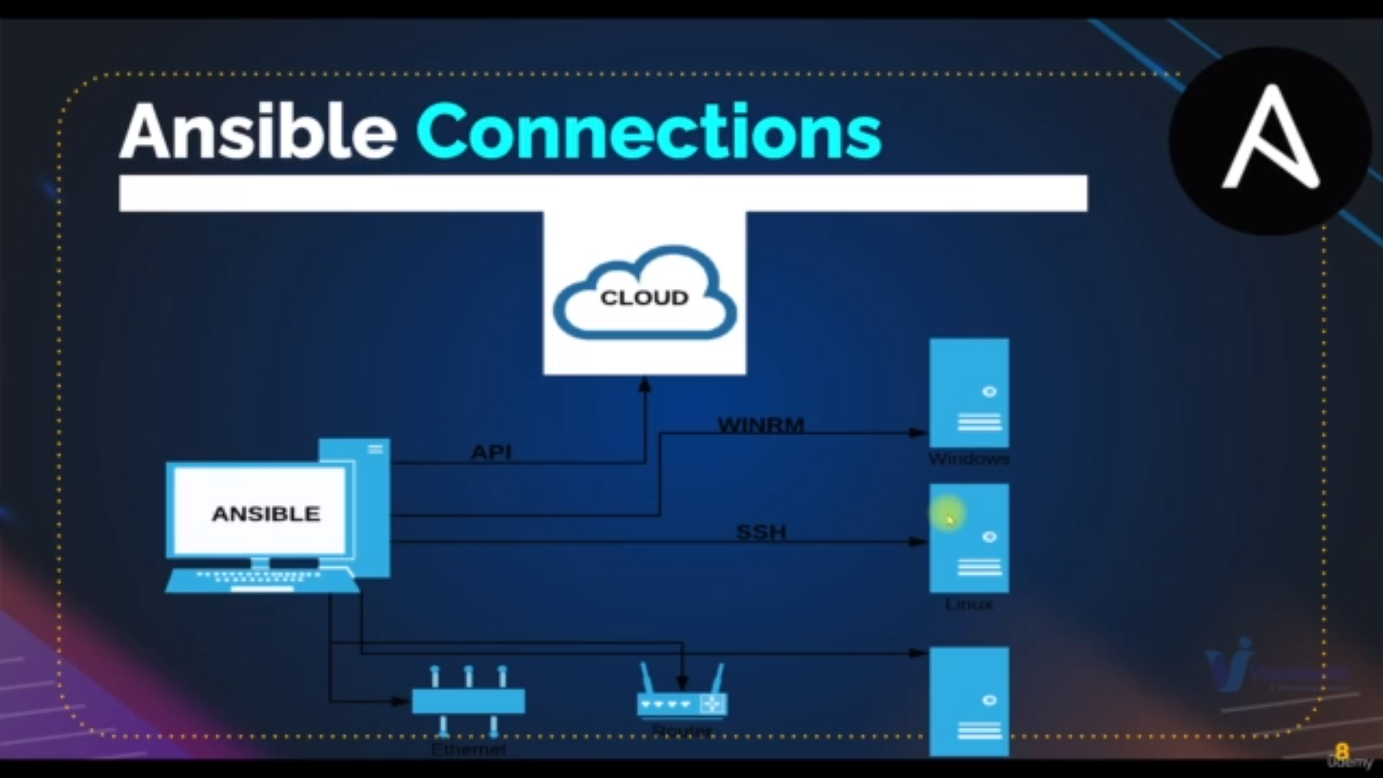ansible also used to manage network device like switches and routers

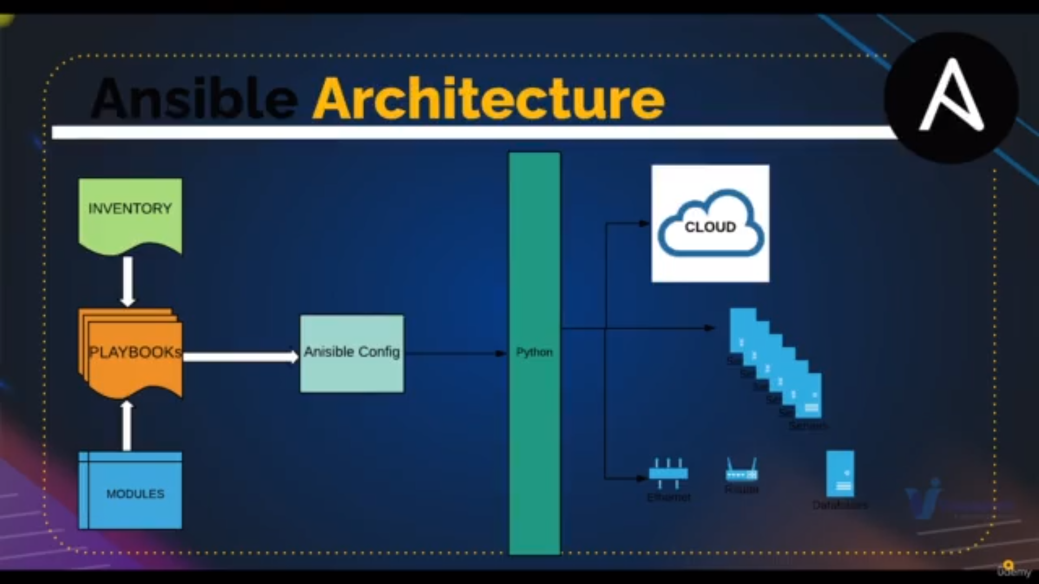we have ipaddress in inventory file of ec2 machines and modules

we’ll write playbooks using yaml where we use modules and excute on ec2machines which are there in inventory file

when we are excueting playbooks these are converted into python scripts and execute

ansible is simple to use

ansible has lots of features